ITUE203: WEB DEVELOPMENT FRAMEWORKS 25CS106– Yana


Faculty of Technology and Engineering

Chandubhai S. Patel Institute of Technology (CSPIT) Department of Computer Science & Engineering

Laboratory manual
Academic Year | : | 2026-27 | Semester | : | 3rd

Practical - 05

PROBLEM STATEMENT :
Create a student registration form with HTML5 input types and JavaScript validation for name, email, mobile number, password, confirm password, course, year, gender, and terms acceptance. Use Regular Expression for validations.
OBJECTIVE:
To design and develop a student registration form using HTML5 and JavaScript with regular expressions (Regex) for validating user inputs, checking password strength, and displaying user-friendly error messages near the relevant fields.
Code:
<!DOCTYPE html>
<html lang="en">
<head>
<meta charset="UTF-8">
<meta name="viewport" content="width=device-width, initial-scale=1.0">
<title>Register Page</title>
<link rel="stylesheet" href="register.css">

</head>
<body>
<div class="container">
<div class="register-box">

<h1>Create Your Account</h1>
<form onsubmit="return validateRegisterForm()">
<div class="form-group">

<div class="field">
<input type="text" id="fullName" placeholder="Full Name">
<span id="s"></span>
</div>

<div class="field">
<input type="email" id="email" placeholder="Email Address">
<span id="s1"></span>
</div>

</div>

<div class="form-group">

<div class="field">
<input type="text" id="mobile" placeholder="Mobile No.">
<span id="s2"></span>
</div>

<div class="field">
<select>
<option>Gender</option>
<option>Male</option>
<option>Female</option>
<option>Other</option>
</select>
</div>

</div>

<div class="form-group">

<div class="field password-box">

<input type="password" id="password" placeholder="Password">

<button type="button"
class="eye-button"
onclick="togglePassword('password', 'eye1')">
<span id="eye1">👁</span>
</button>

<span id="s3"></span>

</div>

<div class="field password-box">

<input type="password"
id="confirmPassword"
placeholder="Confirm Password">

<button type="button"
class="eye-button"
onclick="togglePassword('confirmPassword', 'eye2')">
<span id="eye2">👁</span>
</button>

<span id="s4"></span>

</div>

</div>
<div class="button-box">
<button type="submit" id="registerButton">Register</button>
</div>

</form>

</div>

</div>
<script src="script.js"></script>
</body>
</html>
OUTPUT:
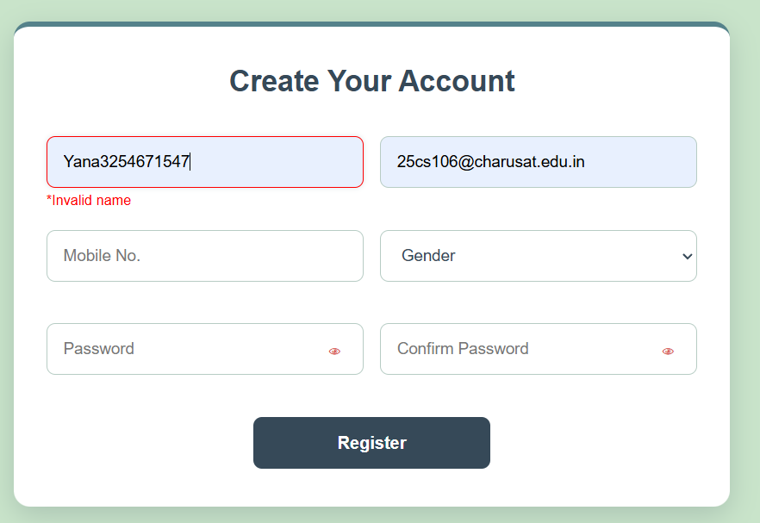
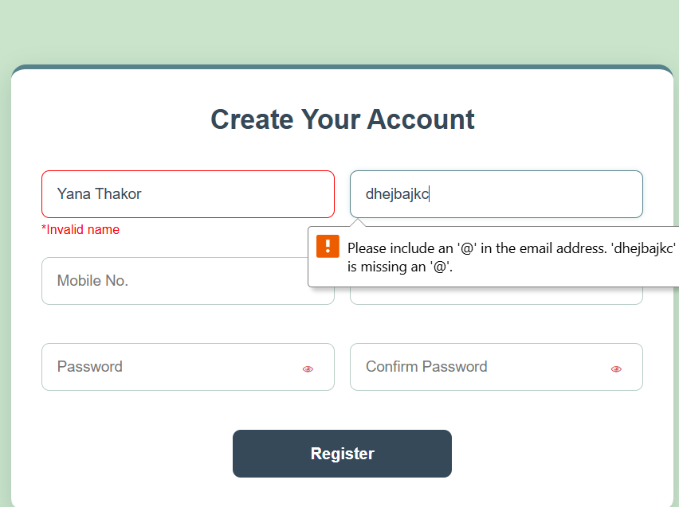
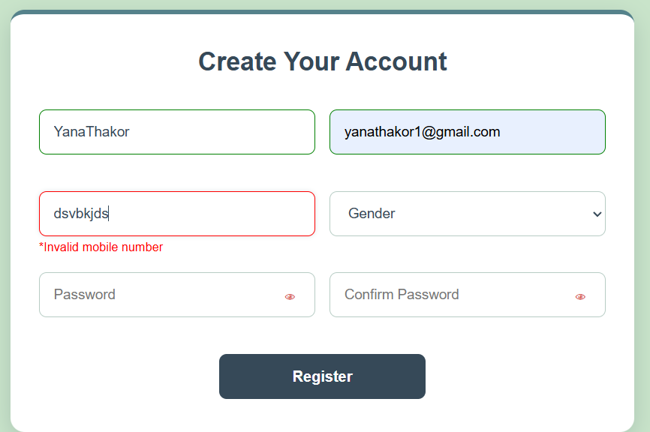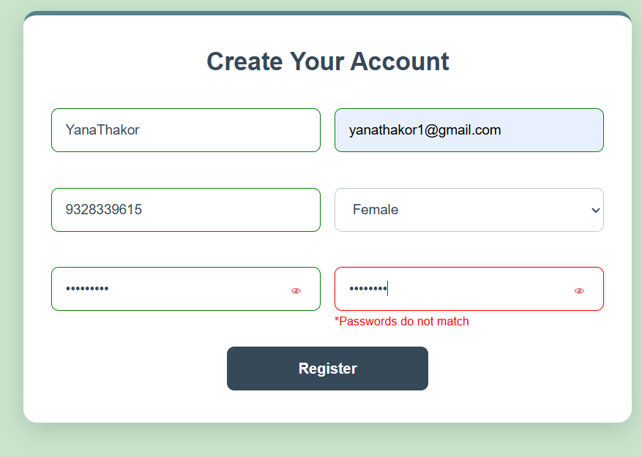

LEARNING OUTCOME:

Successfully developed an accessible student registration form with client-side validation for all required fields, password strength checking, confirm-password matching, and terms acceptance, ensuring accurate data entry and a user-friendly experience.

